Solent University

Coursework Assessment Brief

Assessment Details

Unit Title: | Data Science
Unit Code: | COM603
Unit Leader: | Prins Butt
Level: | 6
Assessment Title: | Data Science
Assessment Number: | 1
Assessment Type: | Software Product with Report
Restrictions on Time/Word Count: | 2500 words
Consequence of not meeting time/word count limit: | It is essential that assignments keep within the time/word count limit stated above. Any work beyond the maximum time/word length permitted will be disregarded and not accounted for in the final grade.
Individual/Group: | Individual
Assessment Weighting: | 100%
Issue Date: | 23rd September 2019
Hand In Date: | 17th January 2020
Planned Feedback Date: | 14th February 2020 (4 working weeks after hand-in)
Mode of Submission: | On-line (via ‘Solent Online Learning’)
Number of copies to be submitted: | 1
Anonymous Marking | This assessment will be marked anonymously

Assessment Task

Global warming is a problem that has been clearly identified as a result of human industrialisation which led to disastrous gas emissions in the atmosphere. The climate is getting warmer each year due to the lack of ozone in the stratosphere and the presence of greenhouse gases.

You have been tasked to present a proposal on how we can tackle the issue of global warming. You should complete and document the following steps:

1. Data Gathering: Gather data from relevant sources and/or utilise suitable datasets for analysis. You may find the following website useful:

https://toolbox.google.com/datasetsearch

Your report should justify your choice of datasets and be informed by research.

2. Data Preparation: Assess the quality of your data using suitable techniques. Clean the data if and as necessary.

You report should document and justify any techniques you have utilised to assess the quality of the data and if necessary clean the data. A Your justification must be informed by research.

3. Data Exploration: Utilise suitable data mining and analysis techniques to find significant patterns and trends. You should write suitable python scripts to support this activity.

Your report should document and justify the techniques you have used to mine and analyse the data and the patterns or trends that were discovered. Where appropriate, findings should be compared to other similar studies.

4. Data Modelling and Visualisation: Construct a model to make predictions and forecast trends. We are essentially interested in tackling global warming and so your model must make predictions or forecast trends that help tackle this issue. You should also use suitable visualisation techniques. It is envisaged that suitable python scripts will be developed for this activity and, if relevant, additional visualisation tools may be utilised.

Your report should document and justify the modelling and visualisation techniques that have been used.

5. Evaluation: Evaluate the results of your findings and put forward a proposal based on your findings.

Your report should clearly present a proposal on how the issue of global warming can be tackled in the context of your findings.

Assessment criteria

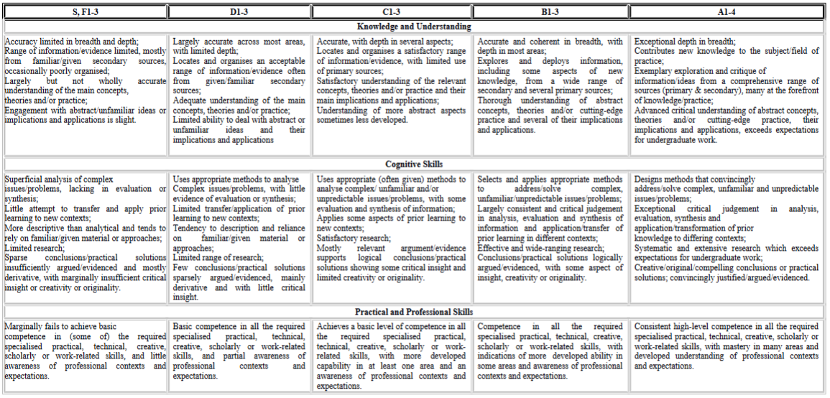

Learning Outcomes

This assessment will enable students to demonstrate in full or in part the learning outcomes identified in the unit descriptors.

Late Submissions

Students are reminded that:

- If this assessment is submitted late i.e. within 5 working days of the submission deadline, the mark will be capped at 40% if a pass mark is achieved;
- If this assessment is submitted later than 5 working days after the submission deadline, the work will be regarded as a non-submission and will be awarded a zero;
- If this assessment is being submitted as a referred piece of work then it must be submitted by the deadline date; any Refer assessment submitted late will be regarded as a non-submission and will be awarded a zero.

http://portal.solent.ac.uk/documents/academic-services/academic-handbook/section-2/2o-assessment-principles-and-regulations.pdf?t=1534423842941

Extenuating Circumstances
The University’s Extenuating Circumstances procedure is in place if there are genuine circumstances that may prevent a student submitting an assessment. If students are not 'fit to study’, they can either request an extension to the submission deadline of 5 working days or they can request to submit the assessment at the next opportunity (Defer). In both instances students must submit an EC application with relevant evidence. If accepted by the EC Panel there will be no academic penalty for late submission or non-submission dependent on what is requested. Students are reminded that EC covers only short term issues (20 working days) and that if they experience longer term matters that impact on learning then they must contact the Student Hub for advice.

A summary of guidance notes for students is given below:

http://portal.solent.ac.uk/documents/academic-services/academic-handbook/section-2/2p-extenuating-circumstances.pdf?t=1534423896787

Academic Misconduct
Any submission must be students’ own work and, where facts or ideas have been used from other sources, these sources must be appropriately referenced. The University’s Academic Handbook includes the definitions of all practices that will be deemed to constitute academic misconduct. Students should check this link before submitting their work.

Procedures relating to student academic misconduct are given below:

http://portal.solent.ac.uk/support/official-documents/information-for-students/complaints-conduct/student-academic-misconduct.aspx

Ethics Policy
The work being carried out by students must be in compliance with the Ethics Policy. Where there is an ethical issue, as specified within the Ethics Policy, then students will need an ethics release or an ethical approval prior to the start of the project.

The Ethics Policy is contained within Section 2S of the Academic Handbook:
http://portal.solent.ac.uk/documents/academic-services/academic-handbook/section-2/2s-university-ethics-policy.pdf

Grade marking
The University uses a letter grade scale for the marking of assessments. Unless students have been specifically informed otherwise their marked assignment will be awarded a letter grade. More detailed information on grade marking and the grade scale can be found on the portal and in the Student Handbook.

http://portal.solent.ac.uk/documents/academic-services/academic-handbook/section-2/2o-annex-2-assessment-regulations-grade-marking-scale.pdf?t=1534424273208

Guidance for online submission through Solent Online Learning (SOL)

http://learn.solent.ac.uk/onlinesubmission

